**1.Write a Python program to calculate the area of a rectangle given its length and width.**

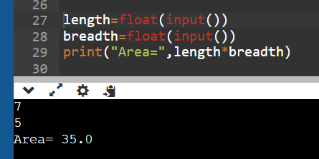

**2.Write a program to convert miles to kilometers**

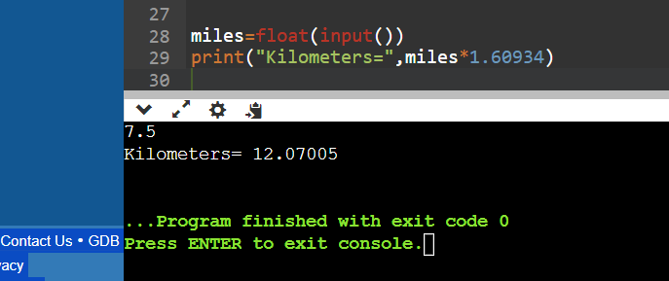

**3.Write a function to check if a given string is a palindrome.**

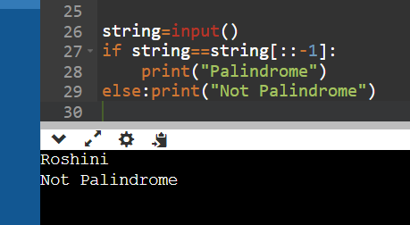

**4. Write a Python program to find the second largest element in a list.**

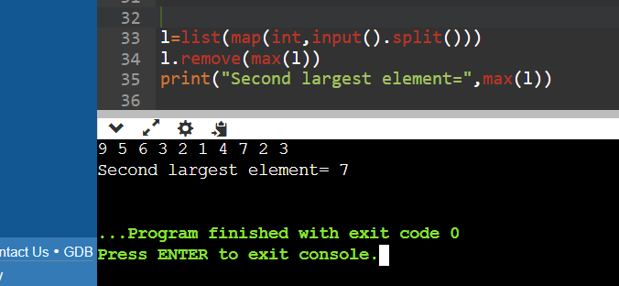

**5. Explain what indentation means in Python.**

Indentation in Python refers to the spaces or tabs at the beginning of a line of code that define a block of code. It is crucial for indicating the scope of statements in control structures like loops and conditionals.

**6. Write a program to perform set difference operation.**

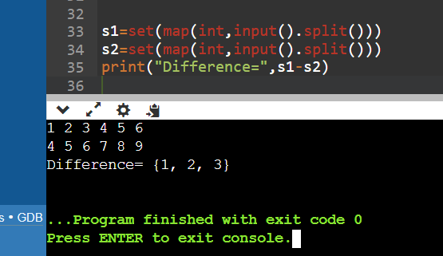

**7. Write a Python program to print numbers from 1 to 10 using a while loop.**

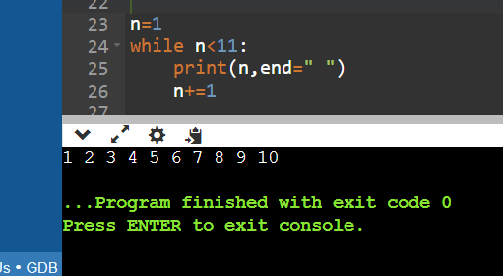

**8. Write a program to calculate the factorial of a number using a while loop.**

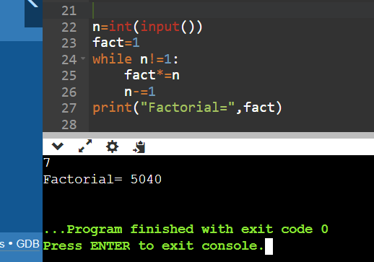

**9. Write a Python program to check if a number is positive, negative, or zero using if-elif-else statements.**

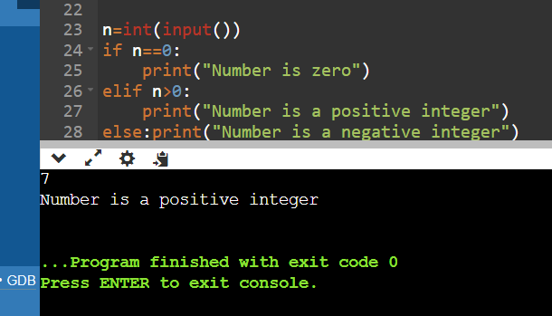

**10. Write a program to determine the largest among three numbers using conditional statements.**

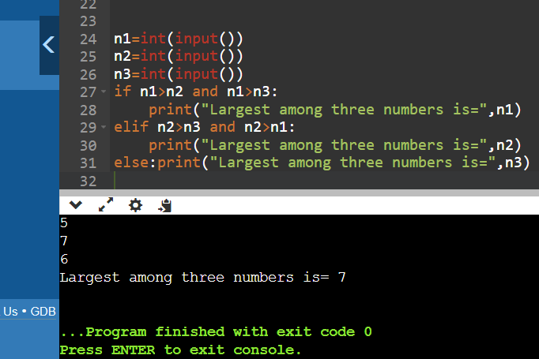

**11. Write a Python program to create a numpy array filled with ones of given shape.**

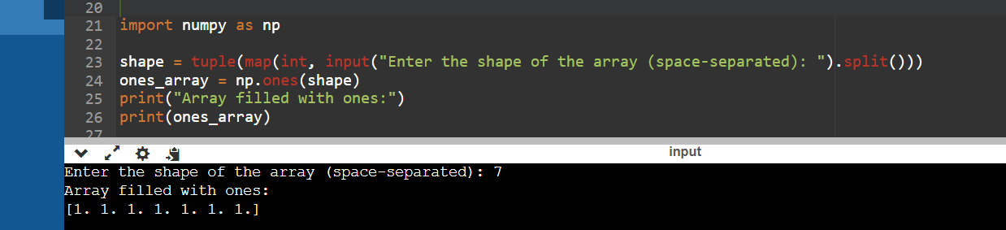

**12. Write a program to create a 2D numpy array initialized with random integers.**

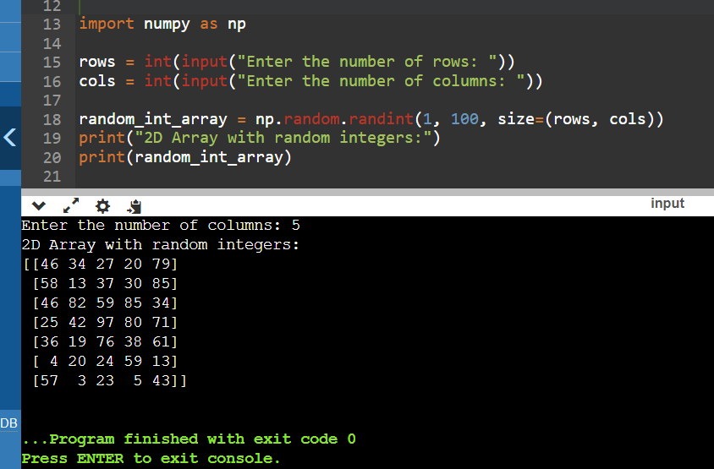

**13. Write a Python program to generate an array of evenly spaced numbers over a specified range using linspace.**

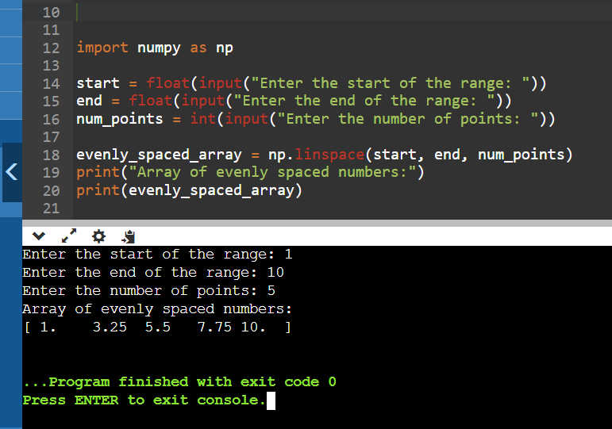

**14. Write a program to generate an array of 10 equally spaced values between 1 and 100 using linspace.**

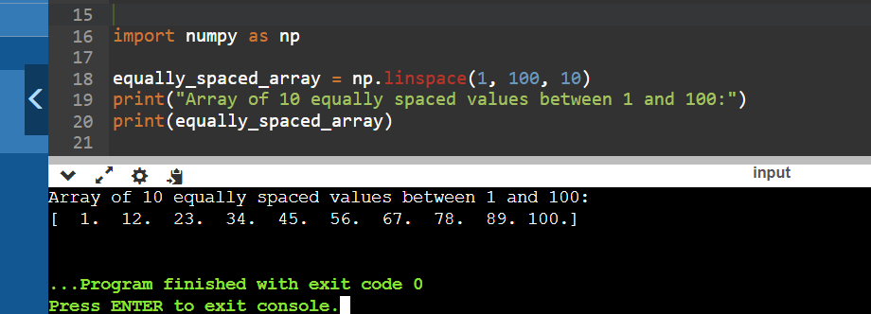

**15. Write a Python program to create an array containing even numbers from 2 to 20 using arange.**

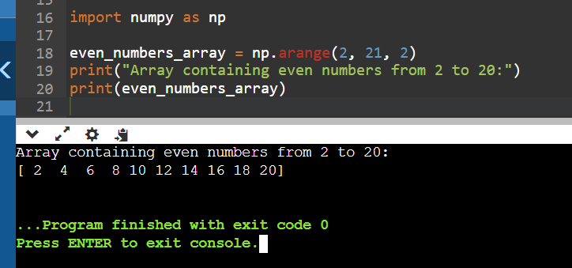

**16. Write a program to create an array containing numbers from 1 to 10 with a step size of 0.5 using arange.**

